Minutes of Cornwall Heritage Trust Property Committee
19th January 2024

The meeting was undertaken via Zoom video-conferencing.
It was chaired by Peter Herring.

Present:
Trustees: Peter Herring and Helen Rawe (late arrival due to computer problems).
Staff: Dick Cole (Sites Officer), Cathy Woolcock (Chief Executive Officer), Hollie Ferris (Countryside Ranger) and James Shipway (Apprentice Countryside Ranger).
Also present: Dawn Hunn.

1.0 Apologies

Apologies were received from Alasdair Moore.

2.0 Minutes of Property Committee from 7th September 2023

The minutes were agreed as a true and accurate record by consensus.

3.0 Report from the Sites Officer

A detailed written report had been circulated to the members of the Property Committee in advance of the meeting. It is attached as appendix 1.

While there was some discussion of all sections of the report, the minutes only cover additional issues raised at the meeting.

3.1 Caer Bran

In addition to the written report, the Sites Officer noted that the new stewardship agreements for the two parts of Caer Bran were for different periods of time, due to the guidance in relation to areas of common land. The eastern segment (incorporating common) has an agreement for ten years, while the western segment is for five years.

It was further noted that the agreement is subject to permission from Natural England to carry out the specified works, due to the SSSI (Site of Special Scientific Interest) status of the site, and even though the Trust already had this consent, we have been advised to submit a new agreement that specifically covers the period of the stewardship scheme (to replace the existing consent).

All present at the meeting were pleased that the Trust could be paid for up to 25 educational visits to Caer Bran per annum. It was clarified that the visits would need to be for, at least, two hours and for schools, and the Trust would be paid £363 per visit. It was further clarified that a number of Trust staff would probably be engaged with this work, included the Sites Team and those involved with education and engagement, and that it could also link to the Trust’s school transport grants scheme.

  - Sancreed Beacon
  - Castle an Dinas
3.4 Luxulyan Valley
3.5 Field at Trethevy

These sections of the report were noted.

3.6 Trevanion Culverhouse

Dawn Hunn noted that the pennywort on the dovecote needed to be treated. The Countryside Ranger stated that this work would be pencilled in for the Spring.

  - St Cleer Well and Cross,
3.8 Lammana Chapel

These sections of the report were noted.

  - Tregonning Hill

There was a more wide-ranging discussion for this site.

The Sites Officer reported back on the recent visit to the Hill, when he and the Countryside Ranger and Apprentice Countryside Ranger accompanied Simon Maddison. Mr Maddison was pleased with his visit. The Chief Executive noted that his financial gift toward the purchase of the site could be one of a number of case studies relating to how gifts and legacies could benefit the work of the Trust.

The Sites Officer also informed the meeting that a community engagement event was being arranged for Saturday 16th March at Balwest Chapel, through which it was hoped to build positive links with the people of the local area.

The CEO added that she had submitted a funding bid to the Bannister Trust for support for works at Tregonning Hill. This included monies for additional staff and the production of an ecological report. In addition, she added that funding for a management plan would be included within the planned application for a stewardship scheme.

In relation to the upcoming Public Inquiry concerning proposed bridleways in the vicinity of Tregonning Hill, it was agreed that the Trust should adopt a broadly neutral position, while keeping a “watching brief” on local opinions and developments.

  - Duloe Stone Circle

The CEO noted that it had taken four-and-a-half years for the lease to be agreed with the Duchy of Cornwall, but was now in place. The Sites Team would soon commence considerations of the works needed at the monument.

Pete Herring noted that a geophysical survey had been carried out at the stone circle. The Sites Officer said that he would forward a copy to him.

  - Continuation of the PLP Volunteer Group
  - Potential new sites

These sections of the report were noted.

  - English Heritage sites

It was reported that, on Thursday (18th January), the Sites Officer had been interviewed at The Hurlers and Trethevy Quoit for the BBC Countryfile programme. He was accompanied by the CEO and Marketing and Communications Officer, while Merv Davey played pipes at the location of The Pipers (part of The Hurlers complex).

The Trust has been informed that the feature will be about four minutes long and it will be broadcast on Sunday 4th February.

  - Other activities

It was noted that the Sites Team was working closely with other members of staff at the Trust. It was stated that there was a good team ethos at the organisation, which was positively welcomed by the trustees.

4.0 Workshop on strategy for sites

The CEO reported that about 15 people would be attending the workshop reating to sites, which would take place on 24th January at the Penventon Hotel in Redruth. It was noted that a similar event for trustees would follow in the future.

5.0 AOB

There was no AOB.

Appendix 1
REPORT TO PROPERTY COMMITTEE OF CORNWALL HERITAGE TRUST
- covering the period from 2nd September until 31st December 2023

The last Property Committee Meeting took place on 7th September and this was reported to Council of Management on 14th September. A report was then produced for the Council of Management on 23rd November, which covered activities in September, October and part of November, but this meeting was cancelled. This report is therefore an updated and extended version of that previous one.

CORNWALL HERITAGE TRUST SITES

1.0 CAER BRAN

1.1 Countryside Stewardship Scheme

The Chief Executive and I have been liaising with Emma Pearce of Natural England about the Higher Level Stewardship Scheme, which we had submitted for Caer Bran. There has been much discussion, particularly because there are “common” rights over approximately 60% of the landholding. An extremely helpful face-to-face meeting was held with Ms Pearce on 6th November and we then received the prescriptions relating to the key options (LH1 – management of lowland heath; SP3 – bracken control supplement; HS4 – scrub control on historic and archaeological features).

The non-common section of Caer Bran (3.5 hectares) will generate approximately £1,500 per annum, while the common section (5.8 hectares) will generate £3,000 per annum. In addition, there will also be payments for up to 25 educational visits to the site. Since the agreement was drafted, the payment levels have increased. Most notably, the payment rate for educational visits (with schools) has gone up from £318 to £363 per visit.

I am pleased to be able to confirm that the agreement is now in place and formally commenced on 1st January 2024.

1.2 Works funded by Historic England

Trustees will recall that Historic England awarded the Trust secured a grant of £19,912 fund bracken clearance, vegetation management, the fencing of the mining remains and interpretation works.

Bracken management ceased in October and I am presently arranging the fencing works with our preferred contractor. These works are due to be carried out this January. Our Marketing and Communications Officer is meanwhile liaising with contractors who are working on an interpretation board for the site.

1.3 Path clearances

The clearance of obstructions at three access points onto Caer Bran was carried out, with the assistance of our stockman and his digger, on 12th September.
1.4 Rubbish removal

When the Sites Team was clearing rubbish from Sancreed Beacon on 22nd-24th November, the Countryside Ranger and Assistant Countryside Ranger also removed dumped metalwork and other materials from within some of the mining hollows on the site.

1.5 Ranger days

The Countryside Ranger had a ranger day at Caer Bran in early November, when volunteers cleared willow from the entrance into the 20th century quarry on the site. There was a follow-up day, when the wood and some scrub was burnt (on tin sheets in the 20th century quarry on the site) (see below).

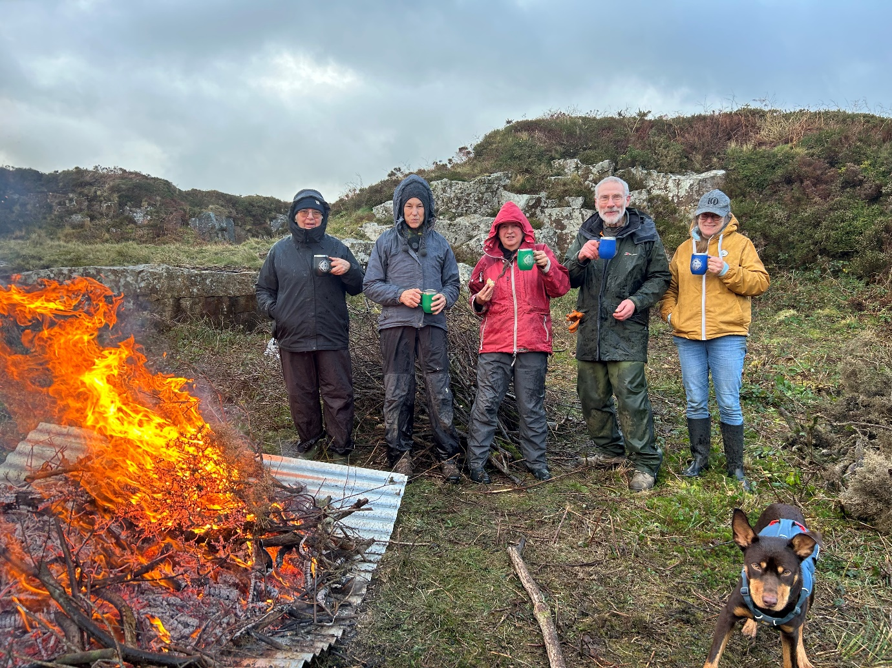

1.6 DMMOs [Definitive Map Modification Orders].

On 12th September, in addition to clearing the blocked gaps in the hedges, I also met Josephine Warburton, the council officer dealing with the request for bridleways across Caer Bran.

It was a helpful meeting and she has since sent me paperwork about the routes across the area, which I am presently reviewing. I hope to have a meaningful verbal update at the meeting.

2.0 SANCREED BEACON

2.1 Agreed enhancements

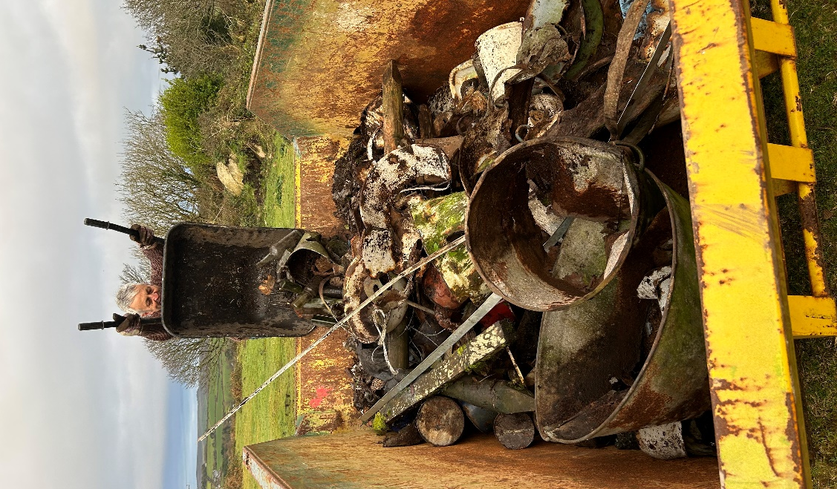
On 22nd-24th November, works were carried out to tidy up areas on the eastern side of Sancreed Beacon.

On 22nd November, the Countryside Ranger and Apprentice Countryside Ranger spread top soil over the dump, from which we removed waste materials during 2022. The purpose of this is to ensure there is a protective layer over the remaining rubbish on the site which includes broken glass.

On the following day, the Countryside Ranger and I, with volunteers, removed dumped materials from the field in the south-east corner of Sancreed Beacon (see right).

The Countryside Ranger and Assistant Countryside Ranger with assistance from our stockman and his digger, also removed dumped tarmac from the area.

2.2 Storage building / pony shelter

The preparation of a planning application for the storage building / pony shelter is my number one priority for January. When I was on site in November, for the clearance works, I met with the owner of the neighbouring property. She is very supportive of the proposal for the storage building and we discussed the proposed location.

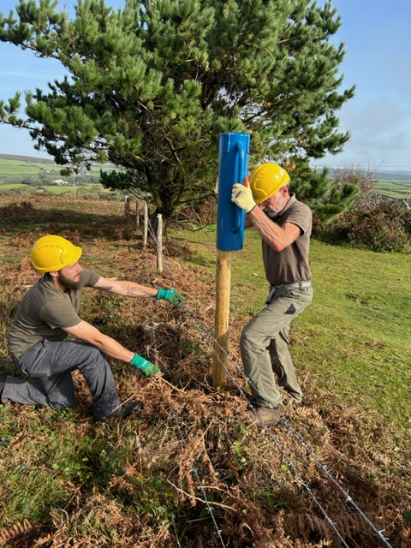
2.3 Ranger days

The Countryside Ranger and Assistant Countryside Ranger held two ranger days at Sancreed Beacon. These related to bracken clearance and fencing repairs (see right). There was also a scything training session.

2.4 Bracken

The Sites Team also conducted considerable bracken clearance in September and early October.
3.0 CASTLE AN DINAS
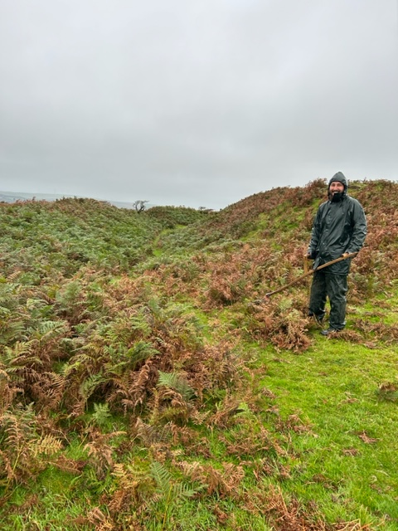
3.1 Bracken

The Sites Team carried out considerable bracken clearance at Castle an Dinas in September and early October (see right).

3.2 Ranger days

The Countryside Ranger held three ranger days at Castle an Dinas. These related to the clearance of bracken clearance and the cutting of gorse.

There was also a corporate volunteering day, involving bracken removal, with members of staff from Cornish Lithium.

3.3 Other activities

As previously reported, there is a scar across the ramparts, directly inside the modern entrance into the monument, caused by people scrambling up into the centre of the fort. Signage asking people not to damage the banks has been damaged, so the Countryside Ranger and Assistant Countryside Ranger have placed gorse in this area to discourage visitors from causing more damage (see below).


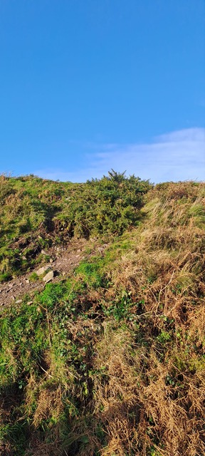

It is still the intention of the Sites Team to work up a volunteer project to record and infill the scars at some point in 2024.

3.4 Other activities

The Sites Team were pleased to assist with the visit of trustees to Castle an Dinas on 14th September, along with the Allantide event on 26th October. The Countryside Ranger and Countryside Ranger Apprentice helped with the entertainment for local children, while I hosted a “ghost walk” for adults in the evening.

In addition, the Countryside Ranger led a guided walk across the site for the Inspiring Women Network.

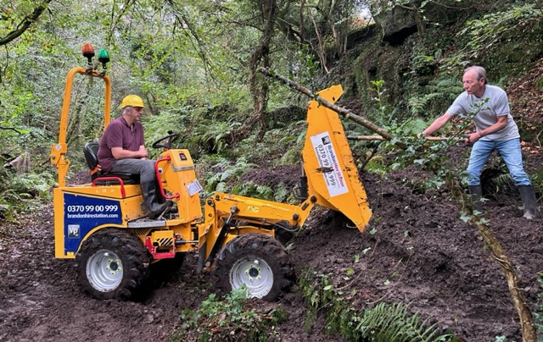
4.0 LUXULYAN VALLEY

The Countryside Ranger and I held three ranger days in the Valley. On two of these, (11th-13th October), we cleared mud from the tramways alongside the actual viaduct, for which we used a mini-digger and small dumper truck, but there is still more work to do.

This is shown by the below photograph (31st October), which shows that following the works, the amount of rainfall meant that the tramway became completely flooded.

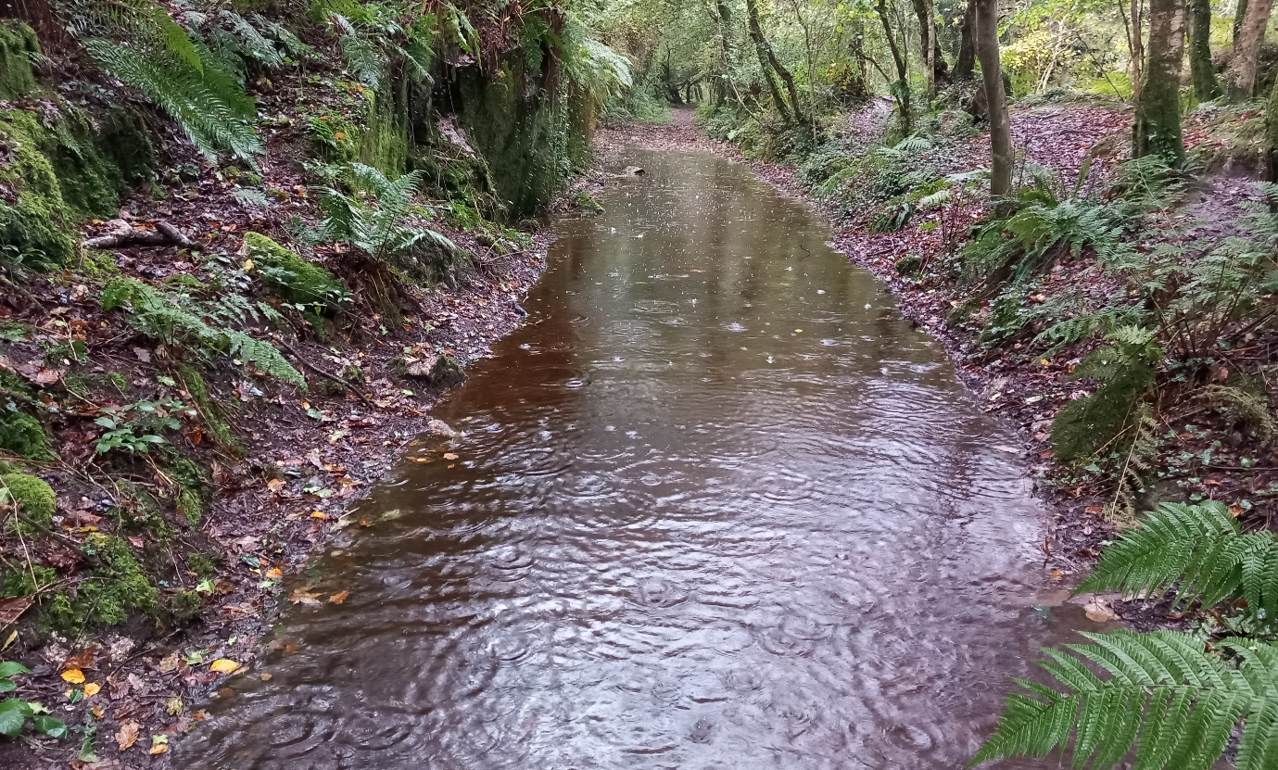

The Countryside Ranger also spent a day with the Cornwall Council ranger who cover the Valley, in order to improve relationships between our organisations.

5.0 FIELD AT TRETHEVY

The Countryside Ranger and Countryside Ranger Apprentice held a series of ranger days at Trethevy, for the raking of loose grass and hedge management. Significant work was done on cutting back and laying the vegetation on the hedges (see below).

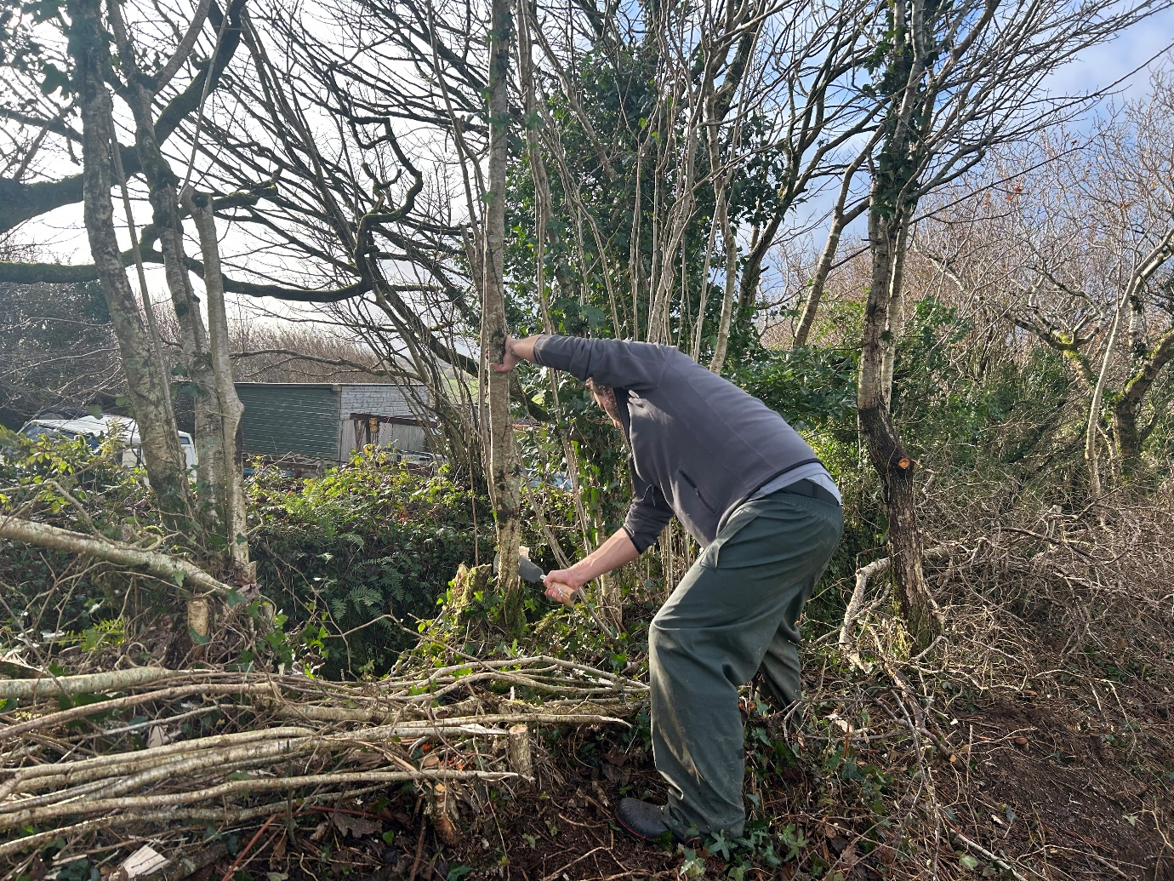

6.0 TREVANION CULVERHOUSE

There are no updates of note in terms of the management of the dovecote, but I can report that our Marketing and Communications Officer is liaising with contractors who are working on an interpretation board for the site.

7.0 ST CLEER WELL AND CROSS

There are no updates of note for this site, though work is ongoing on an interpretation board for the site through our Marketing and Communications Officer.

8.0 LAMMANA CHAPEL

In my last report, I was able to confirm that the ownership of the Chapel has been transferred to the Trust from Cornwall Council. At that point, the unitary authority had yet to clear the worst of the vegetation around the monument and complete the erection of a replacement wooden fence. I can report that these works have been finished.

On my visit to check out these works, it was during a period of torrential rain and I therefore did not chose to take any photographs for this report.

9.0 TREGONNING HILL

Trustees will no doubt be pleased that the Trust’s purchase of 70 acres of Tregonning Hill has been announced to the public.

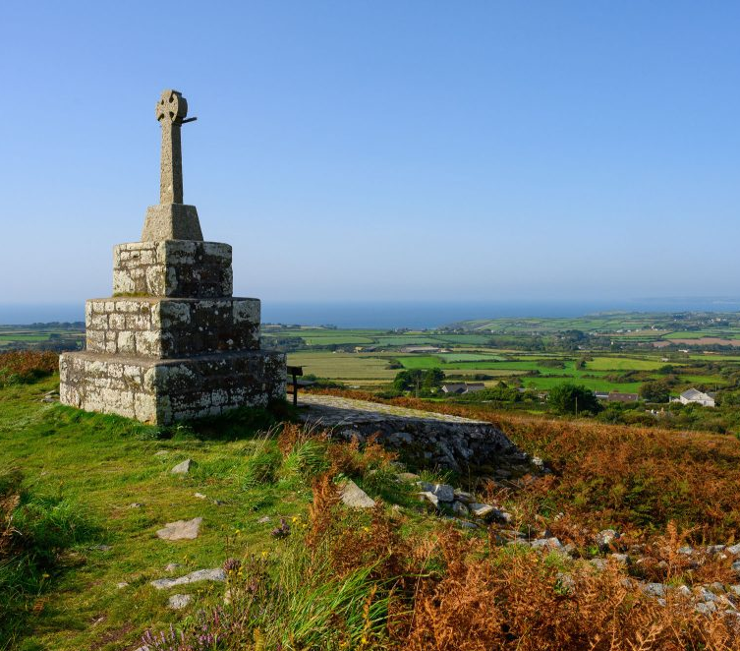

I can confirm that the CEO and I have already started a conversation with Emma Pearce from Natural England about a Higher Level Stewardship Scheme to cover the landholding and it is hoped that a site visit with representatives of the Natural England team can be held in the near future.
Unlike other segments of landscape that the Trust has purchased (eg. Caer Bran), a full archaeological assessment of the site has not been carried out. This is something that will need to be done during 2024, which will also inform other activities including educational visits. The below map shows archaeological features plotted from aerial photographs.
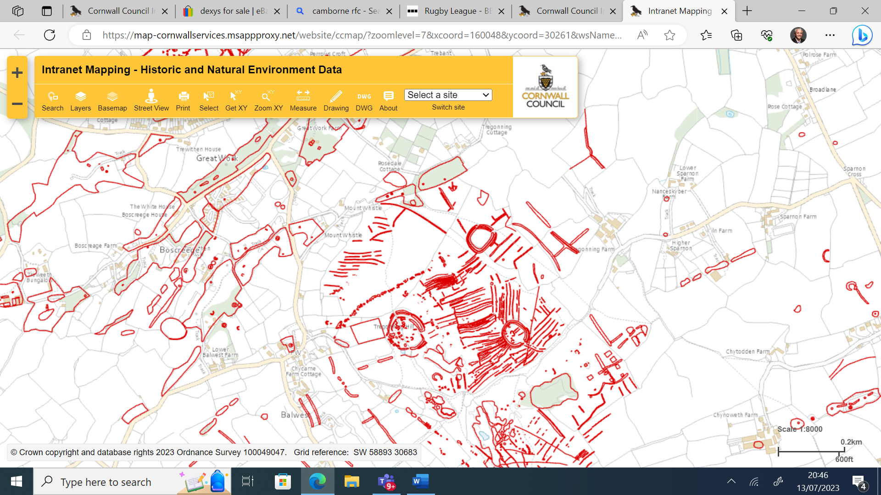

The Sites Team also visited the Hill in early December in order to commence our deliberations about how we understand the land management issues at the site.

Trustees will be aware that Simon Maddison made a significant donation to the Trust to allow Tregonning Hill to be purchased. I can report that on Monday 15th January, the Sites Team will be accompanying Mr Maddison and his wife on a visit to the monument.

In addition, I can report that there is a longstanding proposal for bridlepaths on routes around the land owned by the Trust, which will be going to a public inquiry in early June. These proposals are shown on maps on the next two pages. It is my recommendation that the Trust does not take a view on the proposals. I will explain more at the meeting.
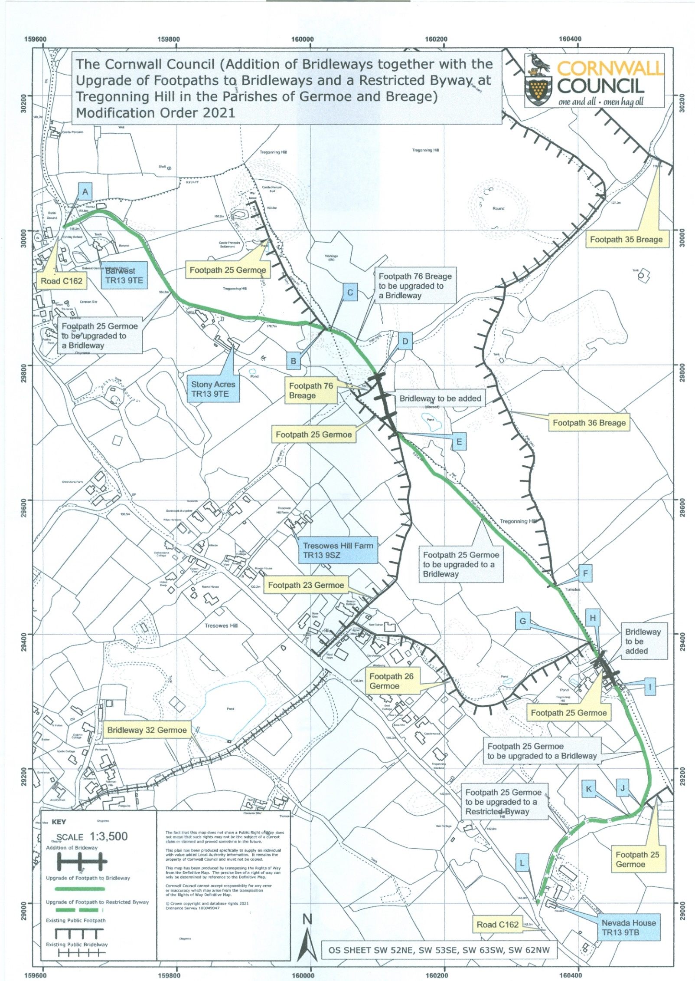

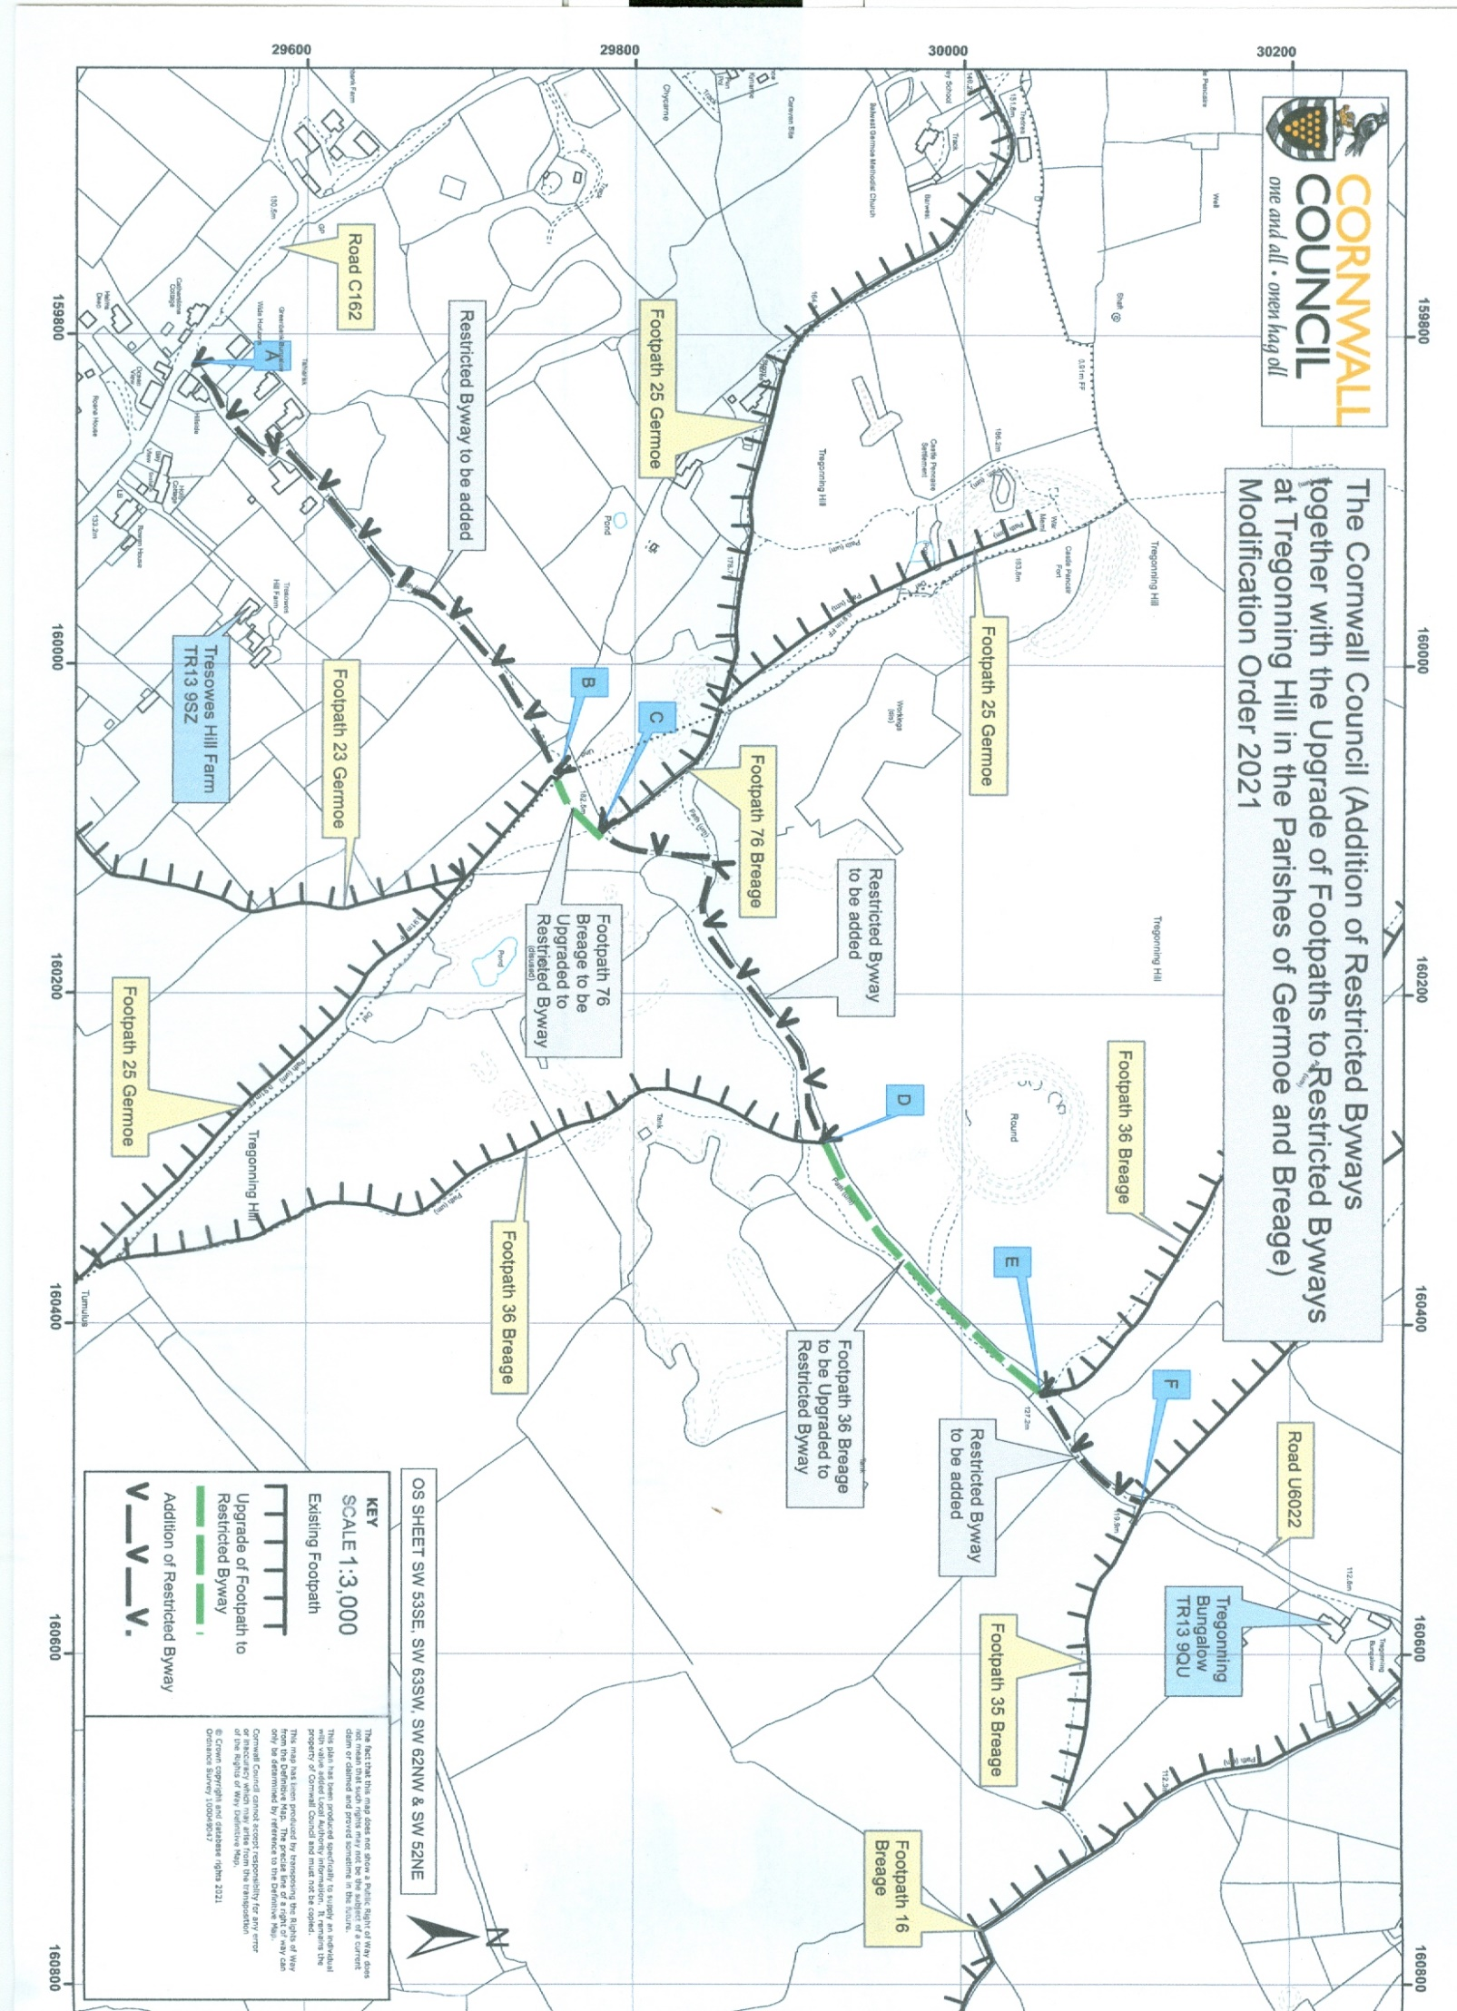
10.0 DULOE STONE CIRCLE

Trustees will also be pleased that the lease to take responsibility for the maintenance of the stone circle at Duloe (and the associated field) has been agreed with the Duchy of Cornwall.

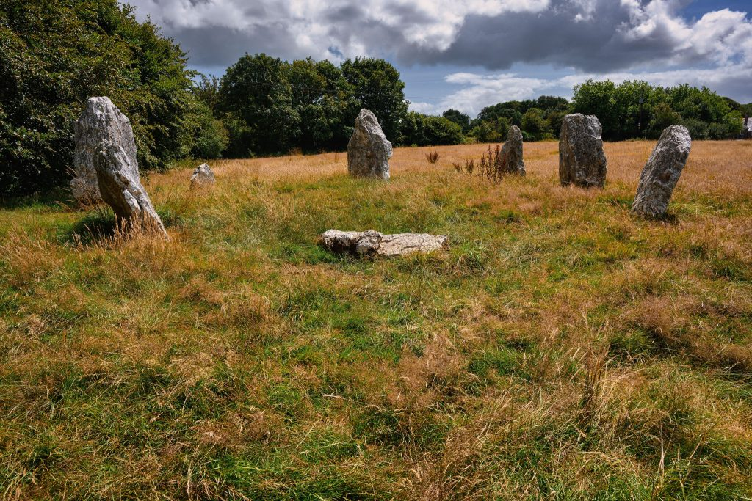

11.0 POTENTIAL NEW SITES

11.1 Castilly Henge

At the last meeting of the Council of Management, it was reported that Historic England had suggested we seek to purchase the henge at Castilly, located off the A30 to the east of Roche. Trustees agreed to make an offer, though I understand it was not deemed enough by the owners of the site. We are presently waiting to see if they might suggest a purchase figure.

11.2 Cornwall Council

At the last Property Committee meeting, the CEO and I reported back on discussions with Cornwall Council about the possible acquisition of sites. In order to further explore the appropriateness of the sites for the Trust, we visited Warbstow Bury in North Cornwall, the Prince of Wales Engine House near Minions, and East Pentire Head, Newquay.

In particular, we felt that Warbstow Bury and the Prince of Wales Engine House would be fantastic additions to the Trust’s portfolio. East Pentire is less impressive, and as a coastal headland has problems with erosion, but Cornwall Council seem willing to discuss the ownership of the car park on the site.

Discussions are also ongoing about the acquisition of the engine house at Minions.

12.0 CONTINUATION OF PLP VOLUNTEER GROUP

I am also pleased that the volunteer group previously associated with the Penwith Landscape Partnership is continuing to do great work under the supervision of Richie Smith. The Countryside Ranger and Assistant Countryside Ranger regularly liaise and work with Richie.

Over the last four months, there have been a range of interventions. These have included Bakers Pit, Bosigran, Chun Castle, Goldherring, Lower Crankan and Mulfra Vean. The associated images show the before and after works at Mulfra Vean.

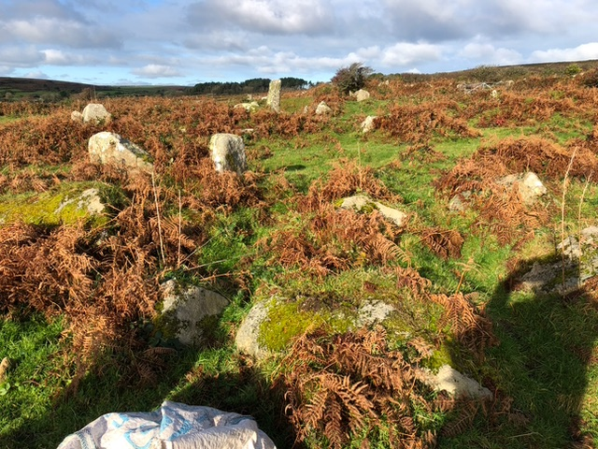

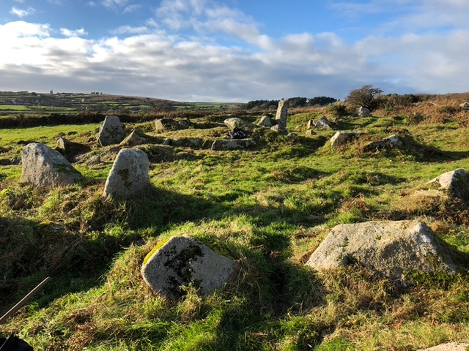

13.0 ENGLISH HERITAGE SITES

The sites team has continued to maintain the seven sites we look after for English Heritage. Works have included the final cut of grass for 2023.
14.0 OTHER ACTIVITIES

The Sites Team assisted with the Awenack Festival, the Heritage Expo at Godolphin House, the Awards Night at Scorrier House and story cafes, as well as hosting school groups at Caer Bran and Sancreed. The Sites Team has also liaised closely with a number of staff members of the Cornwall Heritage Trust for a range of events and activities (including education and promotion of the Trust), and it is noteworthy that the Volunteering Officer has attended a number of the activity days.

The Countryside Ranger and the Countryside Ranger Apprentice recently met with South Cornwall’s National Trust team to network and learn more about their grassland management/ wildflower meadows, and held a further ranger day at which mammal boxes were constructed for our sites. They also led two wreath making workshops for staff and volunteers, from which the wreaths were sold at the Truro Christmas market.

