Minutes of Cornwall Heritage Trust Property Committee
22nd May 2024

The meeting was undertaken via Zoom video-conferencing.
It was chaired by Peter Herring.

Present:
Trustees: Peter Herring and Helen Rawe
Staff: Dick Cole (Sites Officer) and Cathy Woolcock (Chief Executive Officer).

1.0 Apologies

Apologies were received from Alasdair Moore (trustee), Hollie Ferris (Countryside Ranger) and James Shipway (Apprentice Countryside Ranger).

2.0 Minutes of Property Committee from 19th January 2024

The minutes were agreed as a true and accurate record by consensus.

3.0 Report from the Sites Officer

A detailed written report had been circulated to the members of the Property Committee in advance of the meeting. It is attached as appendix 1. While there was some discussion of all sections of the report, the minutes only cover additional issues raised at the meeting.

It was noted that Dawn Hunn is no longer a trustee and therefore she is no longer a member of the Property Committee. The CEO confirmed that she has attempted to make contact with Dawn about a “thank you” lunch, but had had no reply.

  - Caer Bran

This section of the report was noted.

  - Sancreed Beacon

The Sites Officer confirmed that he had had a positive conversation with the planning officer about the prior approval application for the tractor shed.

  - Tregonning Hill
  - Castle an Dinas
3.5 Luxulyan Valley
3.6 Trevanion Culverhouse

These sections of the report were noted.

  - St Cleer Well and Cross

Peter Herring queried the significance of the date for the recent well dressing (eg. was it a saint’s day?). The CEO confirmed that the Trust was simply following the date used by the Old Cornwall Society in previous years
3.8 Lammana Chapel
  - Duloe Stone Circle
  - Field at Trethevy

These sections of the report were noted.

  - Potential new sites

The CEO reported that Cornwall Council was going through internal consultations in terms of the potential transfer of sites to Trust at the moment. Ainsley Cocks from the World Heritage Site team had noted that perhaps the Trust should also seek ownership of the boiler house close to the Prince of Wales Mine. The CEO however confirmed this was not in the ownership of the unitary authority.

  - Continuation of the PLP Volunteer Group

It was noted that it would be good for Richie Smith to attend a future meeting of the Property Committee

  - English Heritage sites

This section of the report was noted.

  - Rural Prosperity Fund

There was discussion about the extent of work that need to be done in the next six-nine months to deliver all the projects included within the RPF grant, including compost toilets, “brown signs” and benches.

  - Other activities
  - Capital Works Plan

These sections of the report were noted.

4.0 AOB

Peter Herring noted potential projects at Castilly Henge and elsewhere involving volunteers from the Cornwall Archaeological Society and queried whether CHT volunteers might also like to be involved.

He also asked whether the Trust should again make enquiries about taking over Penhallam near Bude, another “free” English Heritage site.

5.0 Future meetings

It was also noted that the next two Property Committee meetings would be on 31st July 2024 (2.00) and 23rd October 2024 (2.00).

REPORT TO PROPERTY COMMITTEE OF CORNWALL HERITAGE TRUST
- covering the period from 1st January until 20th May 2024

Produced by Heritage Sites Officer

CORNWALL HERITAGE TRUST SITES

1.0 CAER BRAN

1.1 Fencing of mining remains

The grant for 2023/2024 from Historic England included funding for the fencing of the main area of mining remains. These works were carried out in early February by a contractor, Rob Milburn.

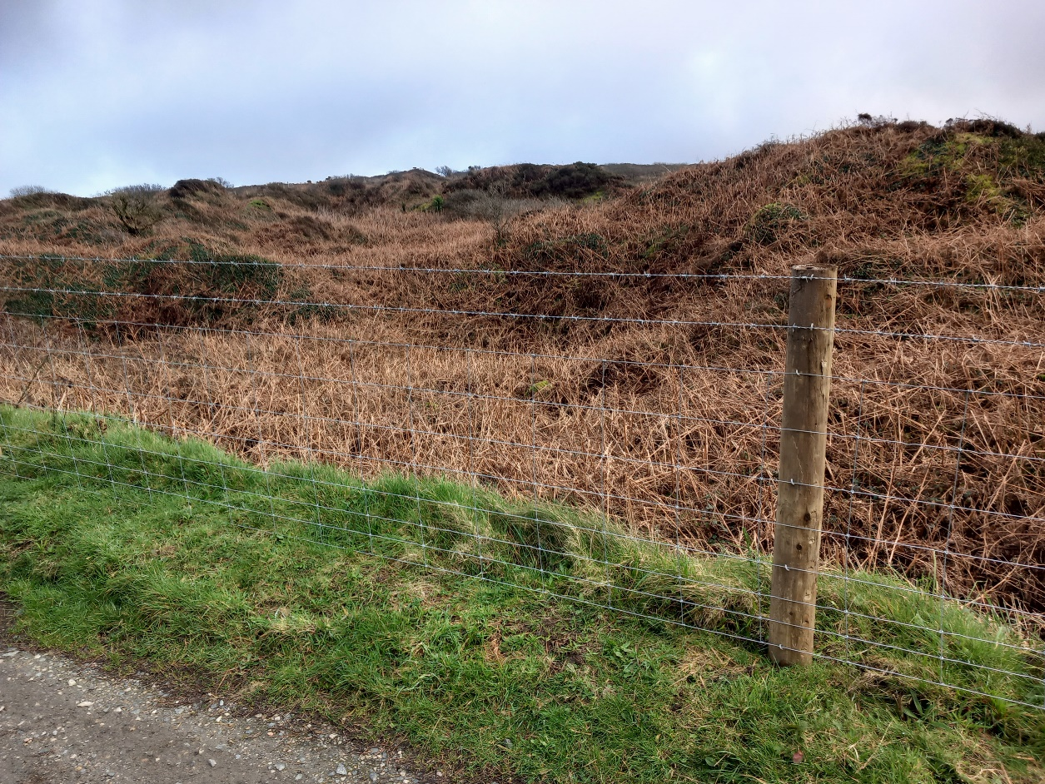

1.2 Cutting of heather

The Countryside Ranger and Countryside Ranger Apprentice used some time in the winter months to cut back areas of heather. These works were recommended in the ecological assessment carried out by Cornwall Environmental Consultants, in order to promote a wider spread of growth heights across the land around the monument.

1.3 New interpretation board

A new interpretation board have been produced and two of them will soon be erected. The Countryside Ranger is presently liaising with Natural England in advance of the works, because of the SSSI status of the land. Ann Preston Jones is also to be contacted because of proximity to the Scheduled Monument.

1.4 Vegetation management

With volunteers, the team cleared gorse over two days in January and also raked up cut heather over a further two days in March and April.

2.0 SANCREED BEACON

2.1 Storage building / pony shelter / compost toilet

As previously reported, the Trust secured funding from the Shared Prosperity Fund for a storage building (for tractor and mower, etc) and a pony shelter. Further funding has recently been confirmed for a compost toilet from the Rural Prosperity Fund.

I have liaised with planning officers and it is my understanding that we have “permitted development rights” to construct the store building, as it relates to agriculture / land management. I have just submitted a “prior approval” application to confirm that we do not need to submit a more formal planning application. The Trust will also need to get consent for the works from Natural England, as it is in the West Penwith Moors SSSI.

The building will be of steel construction, measuring 7m by 6m. It will be 2.8m in height to eaves, with a ridge height of 3.2m.

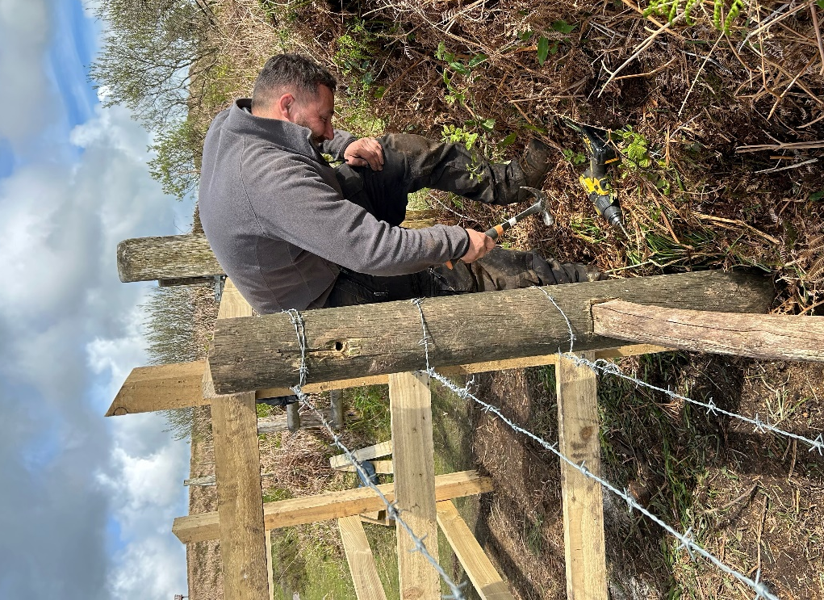
The Countryside Ranger and I had a very positive meeting with Anna Guri from Natural England on 20th May about consent for the tractor store building and the potential location for a compost toilet at the present time

2.2 New kissing gate

This year, we have had a couple of incidents with the ponies “escaping” from the Beacon.

It appears that some people have tied back one of our gates. Because of this, the Countryside Ranger and Countryside Ranger Apprentice improved one of the gates with a new kissing gate. Earlier this month, they also repaired some fencing.

2.3 Vegetation management

The team cleared bamboo and rhododendron over four days in January-March, and two days of coppicing in February, with assistance from volunteers.

2.4 New interpretation board

A new interpretation board has just been finalised and two will soon be delivered. The Countryside Ranger is presently liaising with Natural England in advance of the works, because of the SSSI status of the land.

2.5 Other activities

In addition, the Countryside Ranger hosted a guided walk for the Inspiring Women’s Network in January, while the Countryside Ranger Apprentice hosted a walk in April, when the team also helped out with the “Bunnies on the Beacon” event. There had been a further education session in March with the Education Officer and a group of teenagers building shelters, as well as a “bluebell walk” and foraging workshop in March.

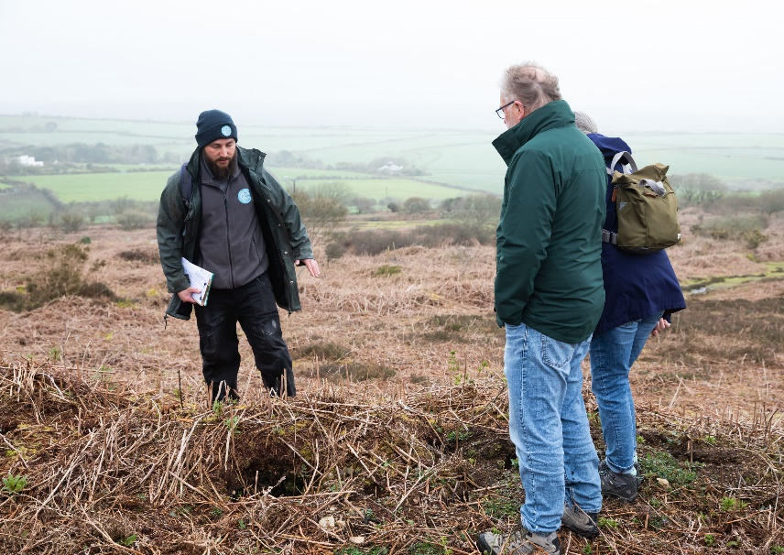
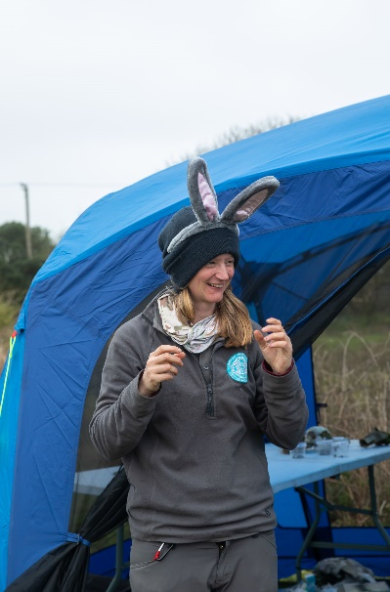

3.0 TREGONNING HILL

3.1 Looking ahead

The Sites Team are presently planning the future management of Tregonning Hill. The Countryside Ranger and I met up with Laura Snell from Cornwall Wildlife Trust on 20th May, as she is doing a free assessment of our landholding as it lies within a “County Wildlife Site.” Her report will cover all the bits that are not SSSI.

Linked to this, we are committed to commissioning an ecological assessment of the site from Cornwall Environmental Consultants. I also need to submit a “notice of works” application to Natural England for what we plan to do on the 25% of the Hill, which is SSSI, though are initial interventions will be in non-SSSI. I am also in the process of organising a site visit with Natural England to discuss an application for Countryside Stewardship funding.
3.2 Community consultation day

The Sites Team joined other staff from the Trust for a consultation at Balwest on 16th March. It was well-attended and there was a great deal of positivity. We made contact with a wide range of local people, some of whom are likely to become future volunteers.

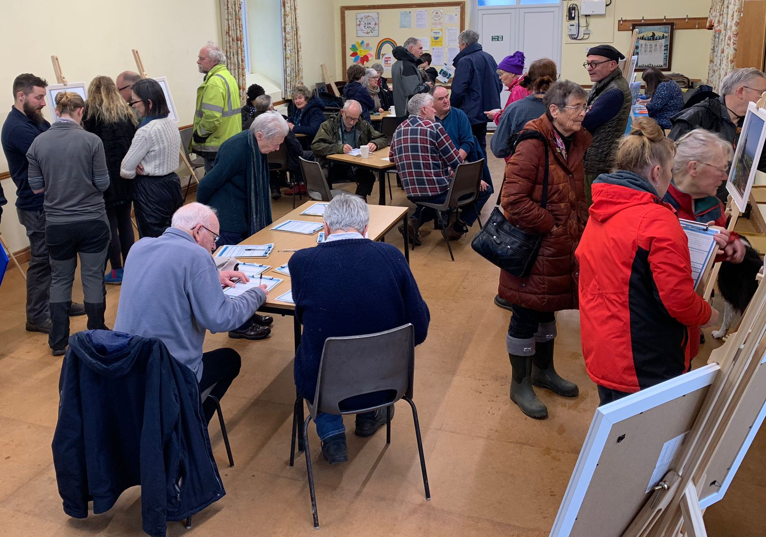

Some local residents had concerns about things such as water run-off from the hill and further conversations are planned for the coming weeks.

4.0 CASTLE AN DINAS

4.1 Storage building / compost toilet

As noted above, funding from the Rural Prosperity Fund has recently been confirmed. It includes monies for a storage building and a compost toilet at Castle an Dinas.

The proposed storage building will be same size and type as the one for Sancreed Beacon. I have just submitted a “prior approval” application to confirm that we do not need to submit a more formal planning application for the storage building.

The toilet building measures 1.9m wide and 2.5m deep, with a height of 2.3m. I can confirm that a full application for this structure has also been submitted.

4.2 New floor for Mine Captain’s Office

It has previously been reported that the wooden floors in the Mine Captain’s Office were extremely rotten. The Countryside Ranger Apprentice has installed a new floor in one of the rooms, so that it can be used as temporary store for some of our tools and equipment.

4.3 Vegetation management

Cut gorse was burned over two days in January, one of which involved volunteers. Grass was mowed on one day in March, which was raked up with volunteers on a second day. The Countryside Ranger and Countryside Ranger Apprentice also carried out a flora survey in May, assisted by volunteers.

5.0 LUXULYAN VALLEY

5.1 Crib Hut

We are pleased to be able to report that conservation works on the Crib Hut have been completed. The contractors were present on the site between 29th April and 3rd May, with the works focused around the soft-capping of the walls. A small amount of work still needs to be done to clear loose stones from around the building, while the nearest (and overhanging) sycamore tree will need to be removed in the Autumn.

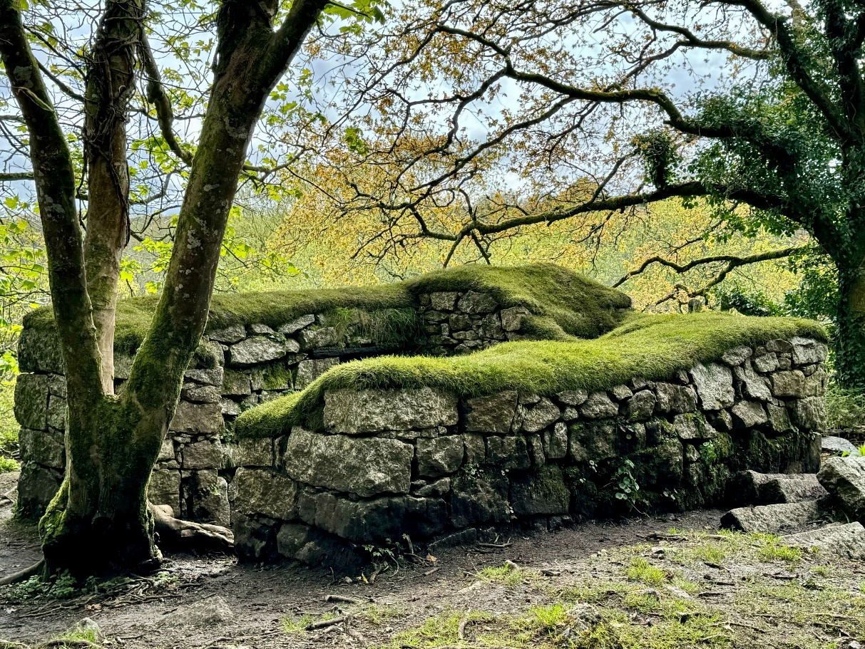

5.2 Walking routes around the Valley

The charity Sustrans has produced a report for Cornwall Council about improving links around the Valley. This included looking at how to improve sections of old tramway, which are inaccessible because of mud. No positive conclusions were offered in this regard, though the Sites Team has also been in the Valley exploring options to improve the surface of tracks in the areas that we own. We will report more when we have come up with proposals.

5.3 Other activities

The Countryside Ranger and Countryside Ranger Apprentice also carried out some treework in the Valley during January, and supported an education day in February.

6.0 TREVANION CULVERHOUSE

An interpretation board for this site has just been completed and will soon be erected. The team is in the process of liaising with Historic England’s Ann Preston Jones about the exact location for the board, because of its proximity to the Scheduled Monument.

Maintenance of the site is ongoing and the growth of pennywort on the structure was recently sprayed.

The Countryside Ranger has raised concerns about the number of small stones falling from the building, and a plan is being put in place to monitor the deterioration and aid future management discussions with Historic England.

7.0 ST CLEER WELL AND CROSS

The Sites Team helped out with the well dressing at the monument in early May. We were responsible for the road closure and putting out the necessary signage.

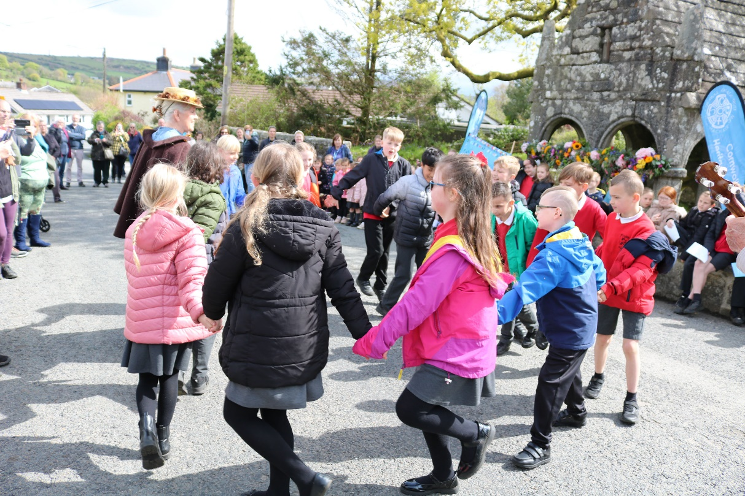

An interpretation board has also been completed for this site and will soon be erected. The team is in the process of liaising with Historic England’s Ann Preston Jones about the exact location for the board, again because of its proximity to the Scheduled Monument.
8.0 LAMMANA CHAPEL

The Sites Team visited the Chapel in Mid March to consider the future management needs of the area. Last year, we had a contact from an individual with an interest in reptiles, who pointed out the positive environment around the monument for this species. The Countryside Ranger is liaising with him about the approach to future vegetation management.

9.0 DULOE STONE CIRCLE

The Sites Team went to the stone circle at Duloe, on the same day as the visit to Lammana, to consider the future management needs of the area. The Countryside Ranger is preparing a plan for works, which can be shared with the owners (Duchy of Cornwall). The first proposed intervention will be to replace the gate to the field, which has collapsed.

10.0 FIELD AT TRETHEVY

The Countryside Ranger and Countryside Ranger Apprentice have done a considerable amount of work in the field at Trethevy. This has included strimming, mowing, tree planting and a biochar workshop.

11.0 POTENTIAL NEW SITES

At the previous Property Committee meetings, the CEO and I reported back on discussions with Cornwall Council about the possible acquisition of sites. These included the Castle an Dinas hillfort and associated land near Ludgvan, Warbstow Bury in North Cornwall, the Housmans Engine House and the Prince of Wales Engine House, both near Minions, land around Lammana Chapel, and East Pentire Head in Newquay. Discussions are ongoing between the CEO and Cornwall Council, and we will report further in the near future.

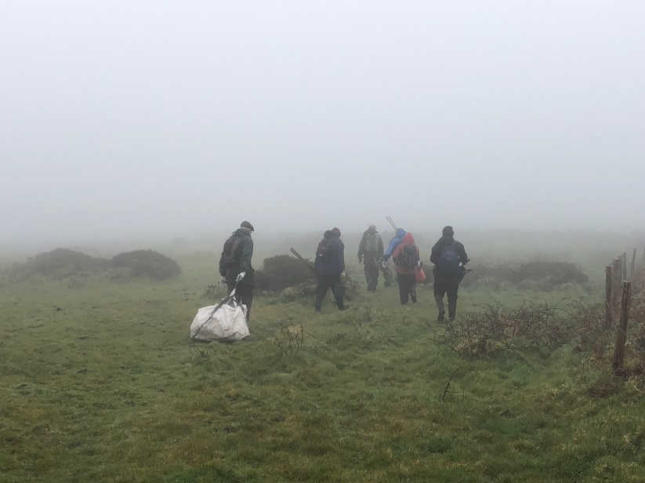
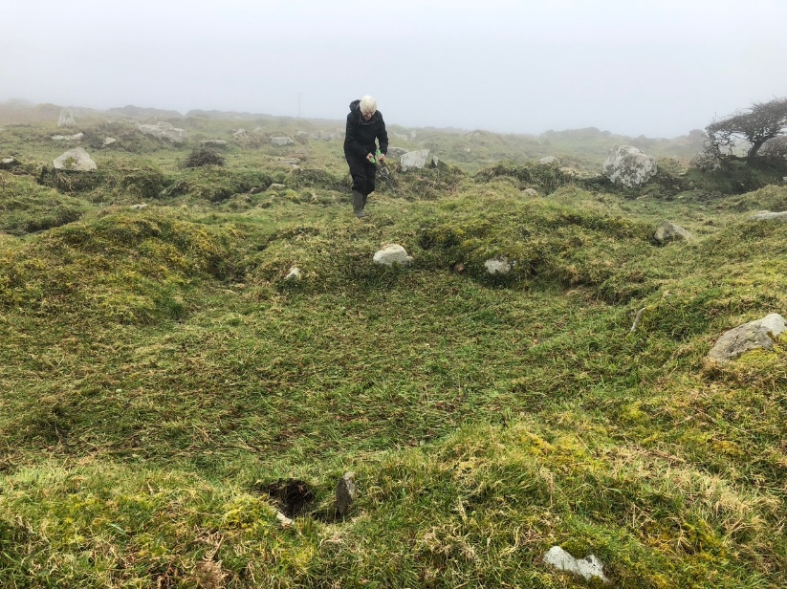
12.0 CONTINUATION OF PLP VOLUNTEER GROUP

The volunteer group previously associated with the Penwith Landscape Partnership is continuing to do great work under the supervision of Richie Smith. The Countryside Ranger Apprentice regularly liaises and works with Richie.

Over the last four months, there have been a range of interventions. The images on this page are from the Bosullow Trehyllys Courtyard Settlement.
13.0 ENGLISH HERITAGE SITES

13.1 Visit of Ed McGregor

On 1st March, Ed McGregor, the English Heritage officer with responsibility for their “free sites” visited Cornwall for his regular monitoring visit. The Countryside Ranger Apprentice and I accompanied him on a visit to the sites in East Cornwall. He is happy with the work that we are doing and particular discussions focused on moving the interpretation board for Trethevy Quoit into the field (from outside the hedge), further weeding works at Carn Euny and the need to update our site-specific risk assessments.

13.2 Works at Trethevy

Following on from previous conservation work on the ground around the base of the Quoit, the Sites Team laid additional turf around the stones and reprofiled two areas where dogs were causing erosion.

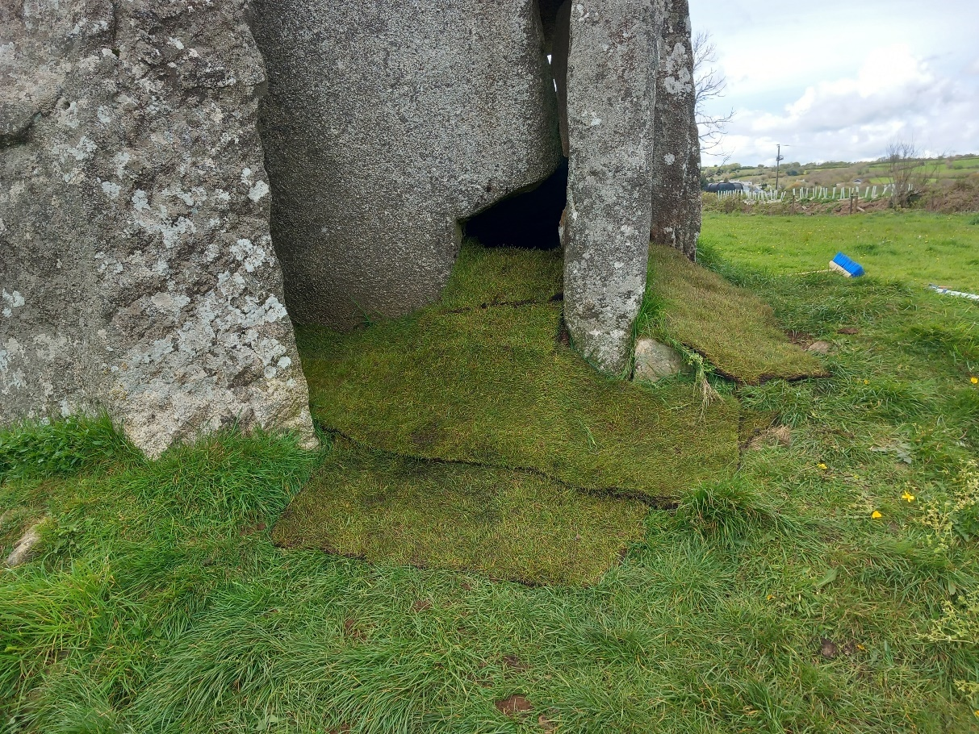

13.3 Small stones

We have also had a reoccurrence of a problem, with people throwing small stones onto the top of the Quoit’s capstone. These were removed on the same day that we did the turfing work.

13.4 BBC Countryfile

I was pleased to represent the Trust when BBC Countryfile decided to do a feature on The Hurlers.

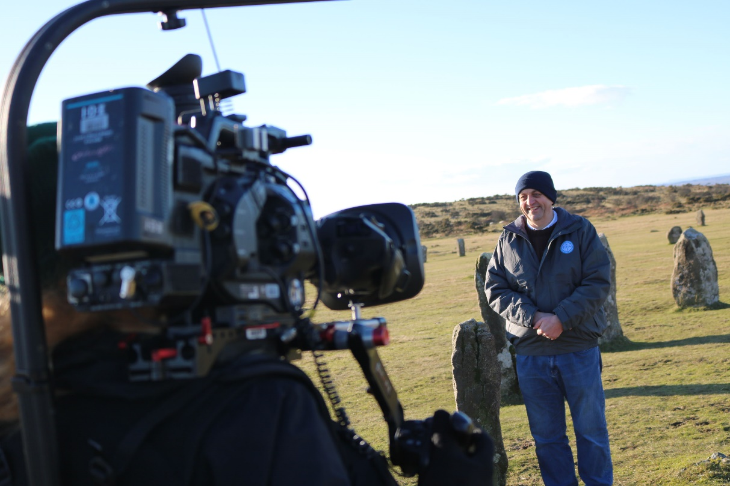

The CEO and our Marketing and Communications Officer helped with the liaison with the BBC, while Merv Davey played the pipes for the film crew at the adjacent Pipers.

14.0 OTHER ACTIVITIES

The Sites Team has been active with a range of initiatives, assisting the wider CHT team. This has included helping with car parking at recent Open Garden events, with the visit to Trefusis being particularly busy.

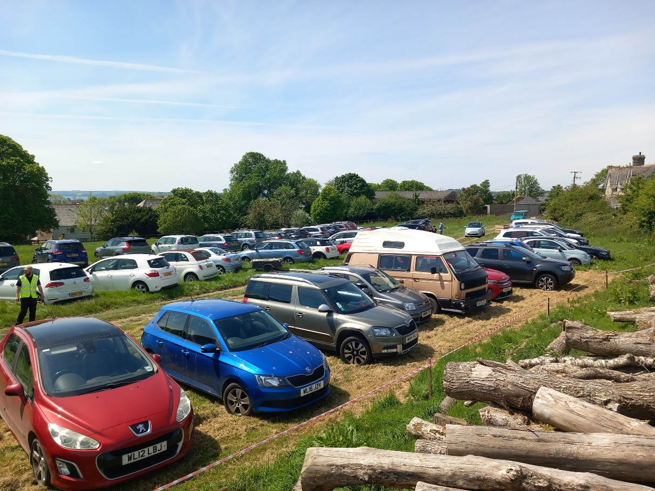

The Countryside Ranger and Countryside Ranger Apprentice were involved with the launch of the Climate Action Youth Group Young Rangers Project, and delivered a joint talk for the Godolphin History Club. I meanwhile gave a talk to the Friends of Penlee House in Penzance.

The Countryside Ranger and Countryside Ranger Apprentice have also attended training opportunities. These have included a harvest mouse surveying training day (National Trust, Lansallos), a birdsong workshop (Cornwall Wildlife Trust, Helman Tor) and a biological recording Conference at the university in Penryn. All three members of the team attended traffic management training and all three of us got a 100% mark.

The Countryside Ranger Apprentice has also attended his college placement, which is part of his apprenticeship, while he has also done some work experience (fencing) with the Lost Gardens of Heligan.

15.0 RURAL PROSPERITY FUND

I have already noted the monies secured from the Rural Prosperity Fund. In addition to the store building and compost toilet for Castle an Dinas, there is also a financial resource for a new trailer, benches for five of our sites, new “brown signs” for six of our sites, and “people-counter” devices for three sites.

The team will soon be looking at how we approach the delivery of these elements of our site infrastructure.

16.0 CAPITAL WORKS PLAN

I have been asked to prepare a detailed capital works plan for the sites. I have not done this yet, but will circulate a draft by email when I have completed the document.

17.0 FUTURE MEETINGS

The next two meeting dates have been set for the Property Committee and are as follows:

31st July 2024 – 2.00
23rd October 2024 – 2.00

